Exercise #1

Show the product ID, product name, list price and standard cost of all products with a standard cost greater than zero. Be sure to show this in the format displayed in the figure below, with correct currency formatting and labels for the columns. Note: your result set should produce a total of 304 rows:

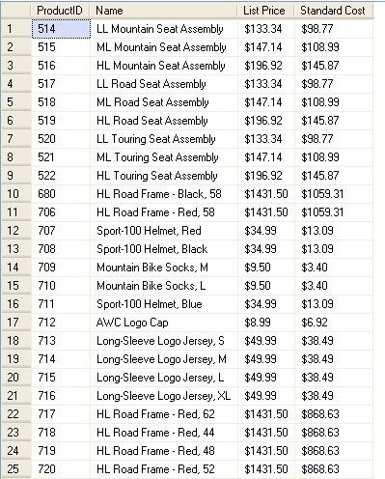

Exercise #2

Show the product category, subcategory, name, and ID for all products that belong to a category and subcategory. These should be sorted alphabetically by category, within category by subcategory, and within subcategory by product name. The results should look like this, and there should be a total of 295 rows in the result set:

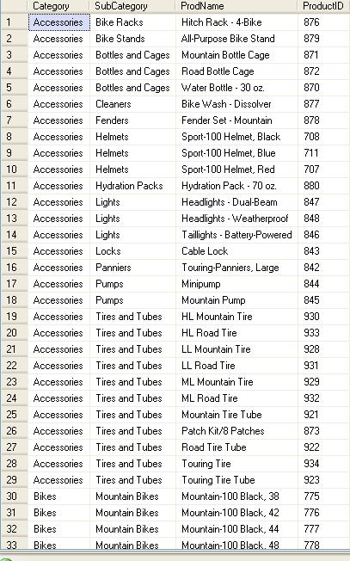

Exercise #3

Modify the query in Exercise #2 so that it includes products that do not belong to a category or subcategory. In this case ALL the products should be included in the result set. How many products would that be?

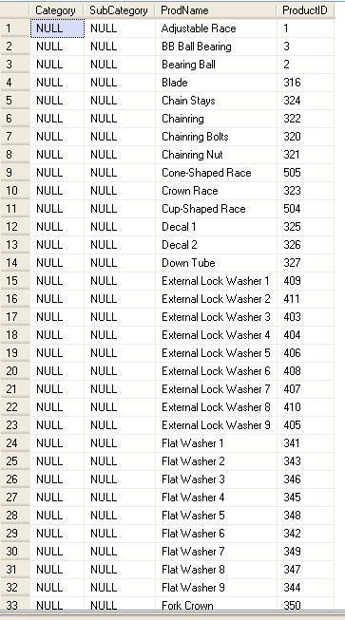
Exercise #4

Show the total number of products in each product category, including those that are not categorized at all. The result set should look like this:

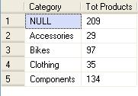

Exercise #5

Show the product ID, subcategory, name and quantity of all bikes (products in the Bikes category) that are currently in inventory, specifically in the Finished Goods Storage location of inventory. The result set be sorted so that the highest quantity items come first and the lowest quantity items come last, so the result set should look like this, with a total of 97 rows:

